**AS 3959 cases**

How radiative heat flux vary with the distance between the front of the fireline and the edge of the forest

|  |
| --- |
|  |

Finding the distance between firefront and the edge of the forest to get targeted BAL limit ob the house.

Interpolation technique was used

|  |  |
| --- | --- |
| FDI | Distance between fire front and edge of the forest (m) |
| 100 | 8.65 |
| 80 | 9.93 |
| 50 | 10.73 |



1. AS 3959: Radiative heat flux on the houses when the distance between fireline and the edge of the forest is 10 m. Here, our objective was to compare the radiative heat flux of the simulations with the given values in AS 3959 for FFDI 100, 80, and 50.

|  |  |  |  |  |
| --- | --- | --- | --- | --- |
|  | Radiative heat flux (kW/m2)- simulation results when fireline to edge of the forest=10 m | | | |
| BAL 40 | BAL 29 | BAL 19 | BAL 12.5 |
| FFDI 100 | 29.07 | 16.37 | 7.67 | 4.33 |
| FFDI 80 | 39.64 | 14.66 | 7.87 | 4.83 |
| FFDI 50 | 47.49 | 20.69 | 9.69 | 4.85 |

Comparison of simulation results and algorithm calculations

|  |  |  |  |  |
| --- | --- | --- | --- | --- |
|  | **Calculated flame angles by the algorithm** | | | |
| **BAL 40** | **BAL 29** | **BAL 19** | **BAL 12.5** |
| **FFDI 100** | 55.206 | 63.842 | 69.05 | 71.452 |
| **FFDI 80** | 56.99 | 65.82 | 71.18 | 73.289 |
| **FFDI 50** | 59.807 | 67.917 | 73.655 | 76.045 |

|  |  |  |  |  |
| --- | --- | --- | --- | --- |
|  | **Radiative heat flux** | | | |
| **BAL40** | **BAL29** | **BAL19** | **BAL12.5** |
| **FFDI 100 Algorithm** | 31.40 | 16.40 | 4.28 | 2.02 |
| **FFDI 80 Algorithm** | 31.29 | 17.31 | 6.12 | 3.92 |
| **FFDI 50 Algorithm** | 30.65 | 19.58 | 9.90 | 4.96 |
| **FFDI 100 simulation** | 29.07 | 16.37 | 7.67 | 4.03 |
| **FFDI 80 simulation** | 39.64 | 14.66 | 7.87 | 4.83 |
| **FFDI 50 simulation** | 47.49 | 20.69 | 9.69 | 4.85 |

Wind speed variation with the distance (Related to Babak Bahrani tree burning experiments)

In this experiment, the initial velocities at the fans are 5.36 m/s (idle wind), 11.17 m/s (medium wind), and 17.88 m/s (high wind). X distance is 7.32 m.

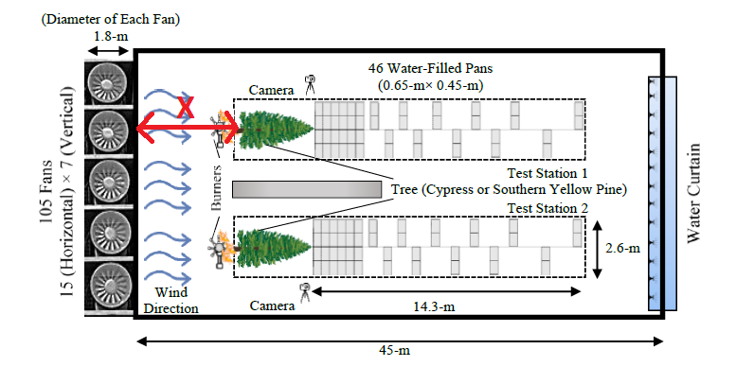

Similar to that, three simulations were completed for given initial wind speeds to find the wind speed at the tree base. The set up is as follows.

|  |  |
| --- | --- |
|  |  |

|  |  |
| --- | --- |
| Inlet velocity m/s (at z=-7.3 m) | Velocity at tree base m/s (at z=0 m) |
| 5.36 | 3.85 |
| 11.17 | 8.19 |
| 17.88 | 13.16 |

3. Compared to Babak’s experiment, to understand the wind velocity variation of AS 3959 along the downwind a few simulations were completed for FFDI 100, 80, 70, 60 and 50. I measured the wind velocity U10 at the inlet, open land U10, wind velocity just before the fireline, middle of the fireline and firefront. No fire has been started at this time. These data were recorded FDS devices and I am still progressing with the MATLAB profiles.